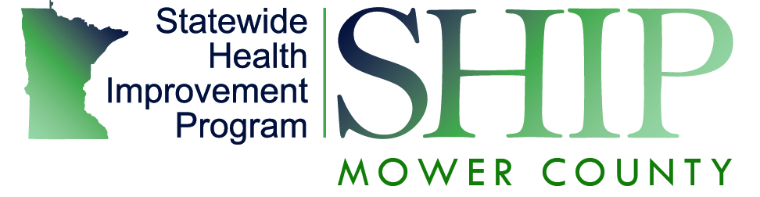
Healthcare Strategy

The Statewide Health Improvement Program (SHIP) is looking to partner with clinics to help reduce the amount of chronic disease in Minnesota. Using prevention mechanisms which will in the long run bring down costs, save money, and foster healthier communities. 75% of health care costs are from diseases/conditions that are preventable. Our local SHIP initiative can help to support your practice in many different ways based on the screen, counsel, refer, and following up process. This process is evidence-based to better prevention practices for clinics statewide.
Screen
As of 2010, 1 in 4 Minnesotans are at risk for obesity related diseases like diabetes.
For clinicians and clinic staff/managers, SHIP local public health coordinators offer training, resources and process analysis on how to incorporate measurement and explanation of BMI into daily practice. SHIP work helps to support system (charting), and environmental (scale, chart, and patient education materials for BMI measurement) changes that integrate screening into daily practice.
Counsel
Beginning with small goals for increasing physical activity or improving nutrition can have significant health benefits. For example, weight reduction of 5-7 percent body weight is associated with lower incidence of diabetes, reduced blood pressure, and improved dyslipidemia.
Compelling evidence is mounting that intensive counseling contributes to lasting health behavior change for sustained weight loss, continued nutrition improvement and persistence with exercise routines. SHIP can help with resources and information on counseling for clinic staff to utilize.
Refer
Local public health SHIP staff can work with clinics to: 1) identify patient resources for physical activity, nutrition, and tobacco cessation; 2) Develop clinic processes for referrals and a referral system to these resources; and 3) Work with clinics and community organizations to implement and evaluate the referral system.
The SHIP clinical - community linkages strategy is aimed at building partnerships between clinics and community organizations to increase referrals to clinic and community based programs and services to help patients eat better, be more active and quit smoking.
Follow-up
Evidenced based programs, either in the community or in the clinic system will work to provide information/feedback to the clinicians on how patients they referred are doing.

